Ryan Farruggia

CSC 35

Professor Ghansah

11 March 2021

Lab Report #5

Image of output using first set of instructions (Input X = 0040, Input Y = 0024):

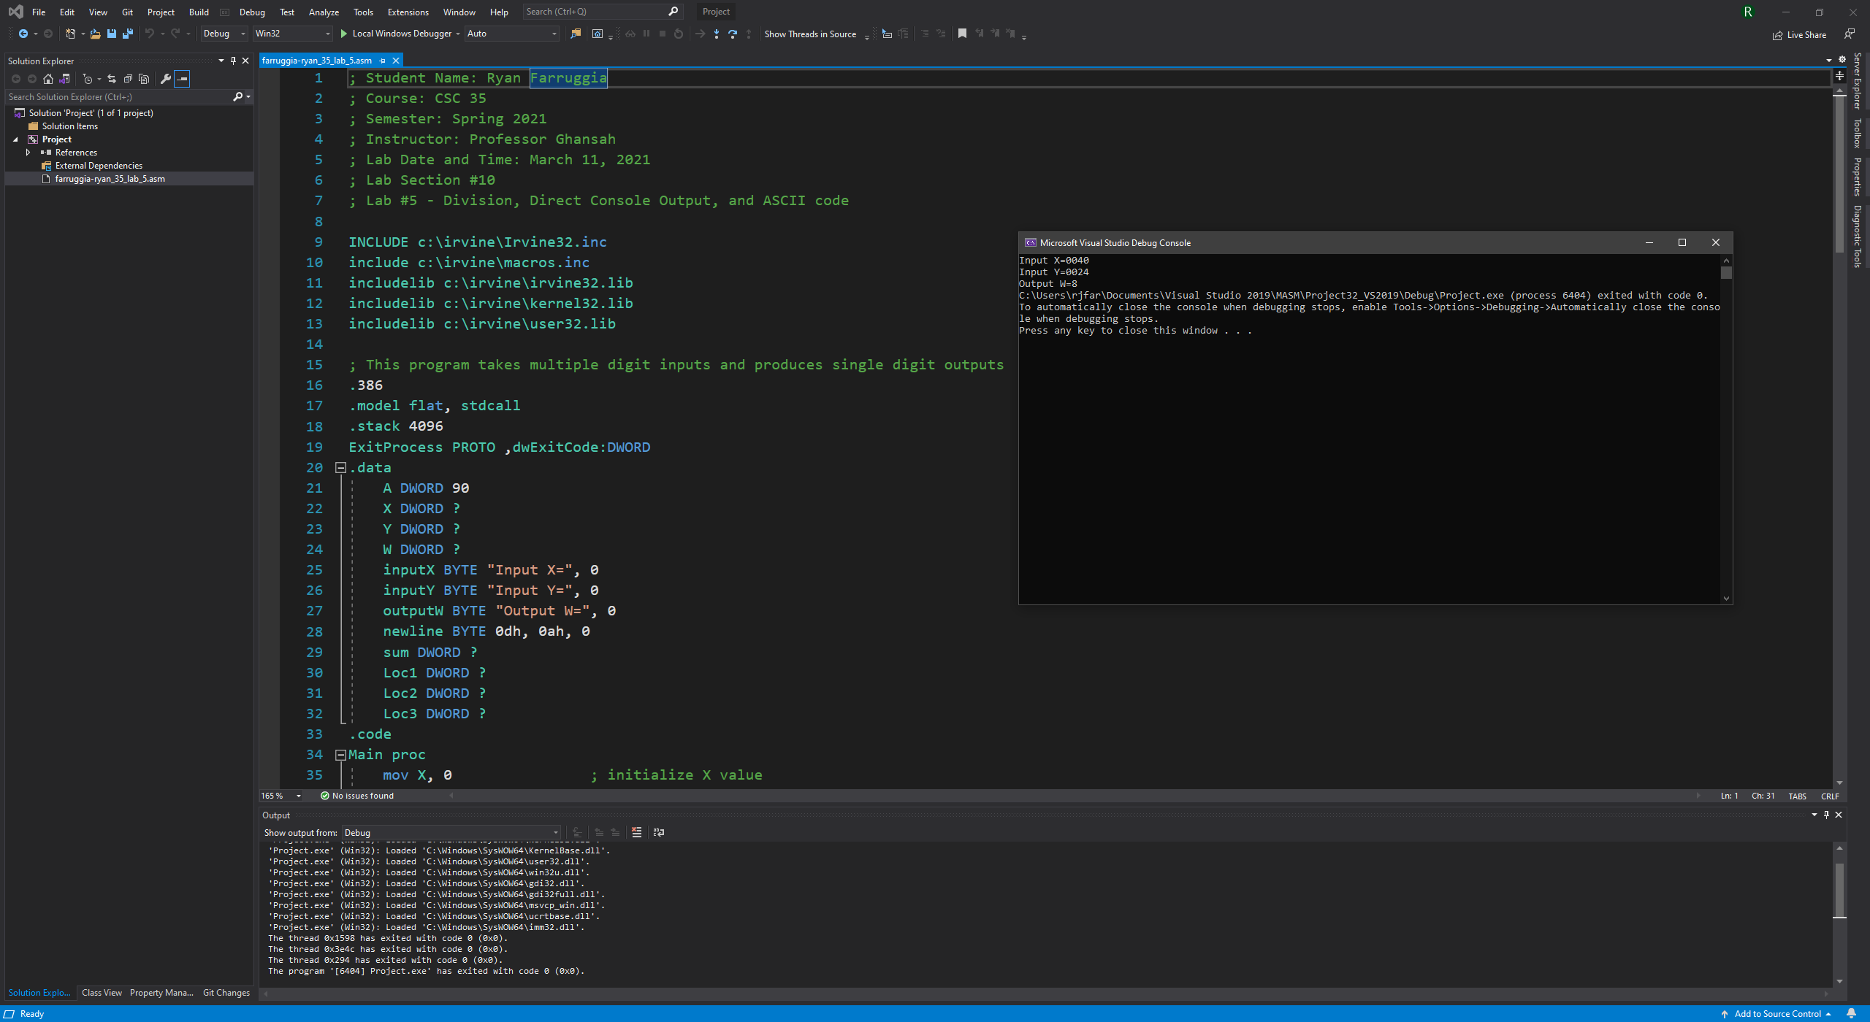

Image of output using second set of instructions (Input X = 0001, Input Y = 0001):

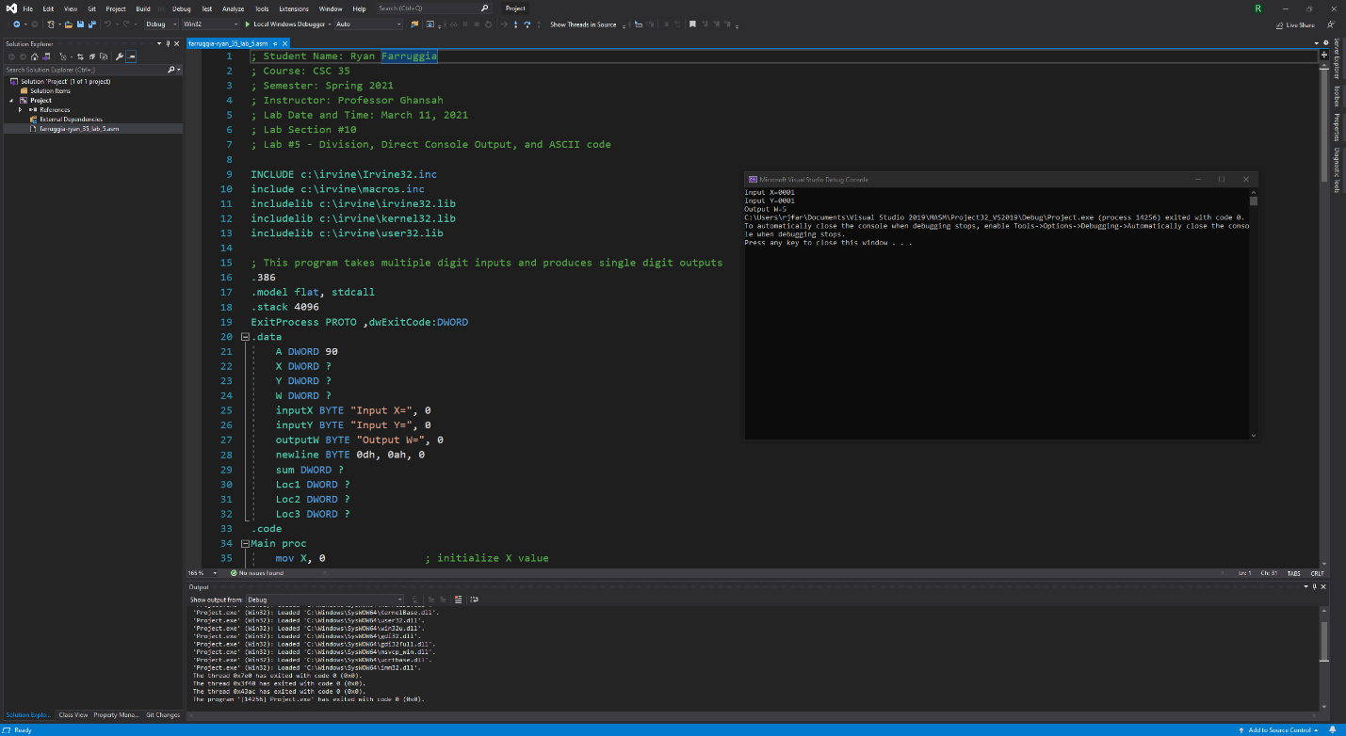

Image of output using third set of instructions (Input X = 1234, Input Y = 0016):

